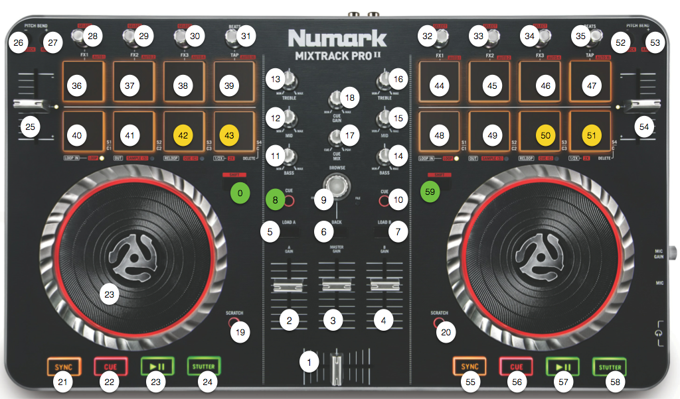

It is a derived version from Numark original one. List of features :

– Remix Deck C/D basic support (capture , trigger, delete, 4×4 slots managed)

– Loop Recorder control

– Filter control for Deck A/B/C/D

– FX1/2 enabler/disabler per Deck

– 8 hot cues manageable per Deck (instead of 3 in original script)

- Additional features like Snap, Quantize, Cruise control mode

